45 Modeling - Text
Text 1
Editing Text 3
Inserting Text 4
Special Characters 4
Convert Text to Text Object 4
3D Mesh 4
Text Selection 5
Formatting Text 5
Fonts 5
Loading and Changing Fonts 6
Size and Shear 6
Objects as Fonts 7
Text on Curve 7
Underline 8
Character 8
Setting Case 9
Paragraph 9
Align 9
Spacing 10
Offset 10
Shape 10
Resolution 10
Fill 11
Textures 11
Geometry 11
Text Editing 11
Text Boxes 11
Frame size 12
Adding/Deleting a Frame 12
Example: Text Flow 13
Example: Multiple columns 13
Assigning Materials 13

Text

Reference
Mode: Edit mode (Text)
Panel: Curve and Surface, Font and Char (Editing context)
Menu: Add ‣ Text

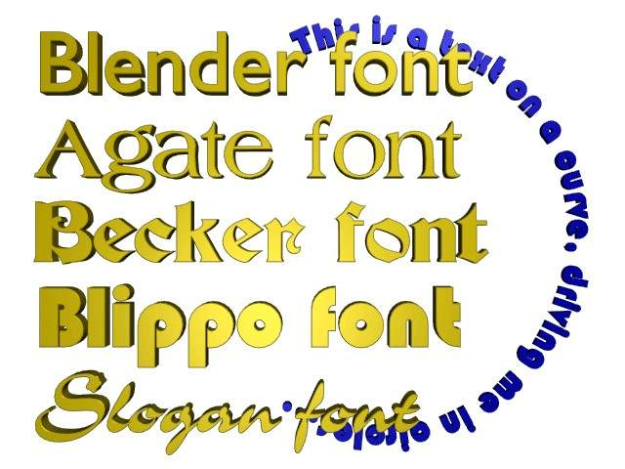
Text Examples.
Text objects are exactly what they sound like: they contain some text. They share the same object type as curves and surfaces, as modern fonts (OpenType, TrueType, etc.) are vectorial, made of curves (generally Béziers).
Bforartists uses a “Font System” to manage mapping “letter codes –> objects representing them in 3D views”. This implies that not only does the font system have its own built-in font, but it can use external fonts too, including PostScript Type 1, OpenType and TrueType fonts. And last but not least, it can use any objects existing in the current .blend file as letters...
Texts in Bender allow you to create/render 2D or 3D text, shaded as you want, with various advanced layout options (like justifying and frames), as we will see below. By default, letters are just flat filled surfaces, exactly like any closed 2D curve. But you can of course extrude them... And texts can follow other curves.
Of course, once you are happy with the shape of your text, you can convert it (with Alt-C, in Object mode), either to a curve, or directly to a mesh, allowing you to use all the powerful features of these types of objects on it...
(Text Examples) shows some examples of various fonts in action, including the “blue” font that has been applied to a curve path.

Note
A maximum of 50000 characters is allowed per text object; however, be forewarned that the more characters a single text object has, the slower the object will respond interactively.
As you can see when you switch between Object and Edit modes, the Font panel remains the same. This means that its settings can be applied equally in both modes ... and this implies that you cannot apply them to just a part of the mesh. So font, size, and so on, are common to all letters in a Text object. There is just one exception: the Bold / Italic buttons control properties specific to each letter (this is a way to use up to four different fonts in a text).
For optimum resource usage, only characters that are being used consume memory (rather than the entire character set).

Editing Text
Reference
Mode: Edit mode

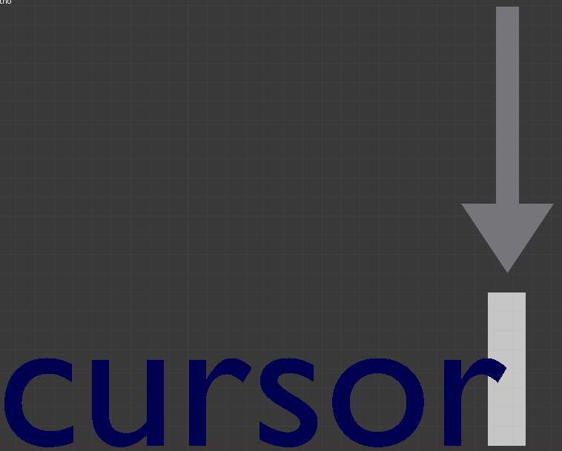
Text in Edit mode.
Editing text is quite different from other object types in Bforartists, and happens mainly in two areas. First, the 3D view, of course, where you type your text, and have a few shortcuts, e.g. for applying styles (see Character) - note however that most Bforartists hotkeys you know in Edit mode do not exist for texts! The second place is the Button window (Editing context), especially the Font panel.
The menu of the 3D view header has nearly no use, and there is no Specials menu... You have no transform nor mirror tools, and so on. However, you can apply to texts the same modifiers as for curves.
Editing Text is similar to using a standard text editor but is not as full-featured and has some differences:
Exit Edit mode
Tab doesn’t insert a tab character in the text, but rather enters and exits Edit mode, as with other object types.
Copy
To copy text to the buffer, use Ctrl-C or the Copy button in the tool shelf.
Cut and Copy
To cut and copy text to the buffer, use Ctrl-X or the Cut button in the tool shelf.
Paste
To paste text from the buffer, use Ctrl-V or the Paste button in the tool shelf.
Delete all text
To completely erase or delete all text, use Ctrl-Backspace.
Home/End
Home and End move the cursor to the beginning and end of a line respectively.
Next/Previous word
To move the cursor on a word’s boundary, use Ctrl-Left or Ctrl-Right.
The text buffer does not communicate with the desktop. It only works within Bforartists. To insert text from outside Bforartists, see Inserting Text below.

Inserting Text
You can insert text in three different ways: from the internal text buffer (Editing Text), or from a text file.
To load text from a text file, use the Text ‣ Paste File tool. This will bring up a File Browser window for navigating to a valid UTF-8 file. As usual, be careful that the file doesn’t have too many characters, as interactive response will slow down.

Special Characters
Reference
Mode: Edit mode
Menu: Text ‣ Special Characters

If you need special characters (such as accented chars, which aren’t on your keyboard) you can produce many of them using a combination of two other characters. To do so, type the main char, press Alt-Backspace, and then press the desired “modifier” to produce the special character. Some examples are given below:
A, Alt-Backspace, ~ | ã | A, Alt-Backspace, ' | á | A, Alt-Backspace, ` | à
A, Alt-Backspace, O | å | E, Alt-Backspace, " | ë | O, Alt-Backspace, / | ø

Convert Text to Text Object
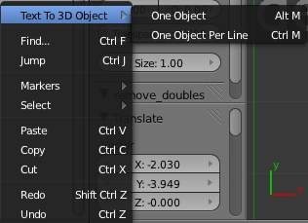
Using an existing text-block, you can convert it to an object from the text editor’s header, select Edit ‣ Text to 3D Object, One Object or One Object per Line depending on your needs.
It is also possible to paste from the clipboard or a file from the Edit menu, while editing 3D Text.

3D Mesh
It is possible to convert a Text Object to a 3D Mesh object. This can be useful so that you may edit the vertices in Edit Mode, but you will lose the ability to edit the text itself. To do this, go to Object Mode and select your Text Object. Press Alt-C and select Mesh From Curve/Meta/Surf/Text. Now you can return to Edit Mode and manually edit the vertices. They are usually a bit messy, so it may be useful to use a Limited Dissolve deletion or Remesh Object Modifier at a low threshold to clean up your mesh.
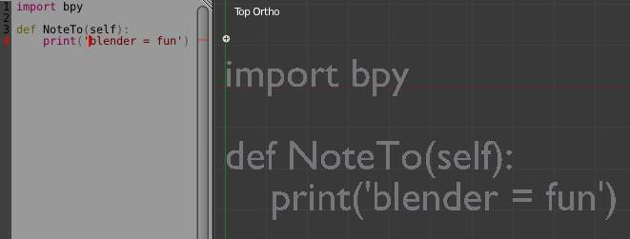
left normal text, right the made text object.

Text Selection
Text in Edit mode.
In Edit mode, your text has a white cursor, and as in any text editor, it determines where new chars will be inserted! You move this cursor with the arrow keys or PageUp / PageDown and Home / End keys.
Hold Shift while using the arrow keys to select a part of the text. You can use it to specify different materials, the normal/bold/italic state, and not much more...

Formatting Text

Fonts
Reference
Mode: Edit mode
Panel: Font (Editing context)

The Font panel has several options for changing the look of characters.

Loading and Changing Fonts
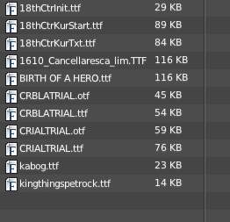
Loading a Type 1 font file.
Bforartists comes with a built-in font by default and is displayed in each of the four font style choosers. The built-in font is always present and shows in this list as Bfont. The first icon contains a drop-down list displaying currently loaded fonts. Select one for each font style.
To load a different Font, click one of the Load buttons in the Font panel and navigate to a valid font. The File Browser window will give all valid fonts a capital F icon, as seen in Loading a Type 1 font file.
Note
Unix note
Fonts are typically located under /usr/lib/fonts, or some variant like /usr/lib/X11/fonts, but not always. They may be in other locations as well, such as /usr/share/local or /usr/local/share, and possibly related sub-trees.

If you select a font that Bforartists can’t understand, you will get the error Not a valid font.
Remember the same font will be applied to all chars with same style in a text, but that a separate font is required for each style. For example, you will need to load an Italics font in order to make characters or words italic. Once the font is loaded you can apply that font “Style” to the selected characters or the whole object. In all, you would need to load a minimum of four different types of fonts to represent each style (Normal, Italics, Bold, Bold-Italics).
It is important to understand that Bforartists does not care what font you load for “normal”, “bold”, etc., styles. This is how you can have up to four different fonts in use in the same text - but you have to choose between different styles of a same font, or different fonts. Bforartists has a number of typographic controls for changing the style and layout of text, found in the Font panel.

Size and Shear
Size
Controls the size of the whole text (no way to control each char size independently). Note however that chars with different fonts (different styles, see below) might have different visible sizes.
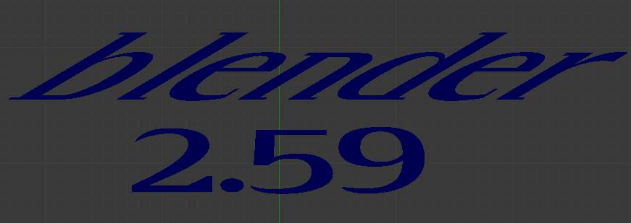
shear: ‘Bforartists’ has a shear value of 1, ‘2.59’ a shear value of 0
Shear
Controls the inclination of the whole text. Even if this seems similar to italics style, this is not the same thing !

Objects as Fonts
You can also “create” your own “font” inside Bforartists! This is quite a complex process, so let’s detail it:
- First, you must create your chars. Each char is an object of any type (mesh, curve, meta...). They all must have a name following the schema: common prefix followed by the char name (e.g. ft.a, ft.b, etc.).
- Then, for the Text object, you must enable the Dupli Verts button (Object context - Anim Settings panel).
- Back in Editing context, in the Font panel, fill the Ob Family field with the common prefix of your “font” objects.
Now, each time a char in your text matches the suffix part of a “font” object’s name, this object is duplicated on this char. The original chars remain visible. The objects are duplicated so that their center is positioned at the lower right corner of the corresponding chars.

Text on Curve
With the curve modifier you can let text follow a curve.
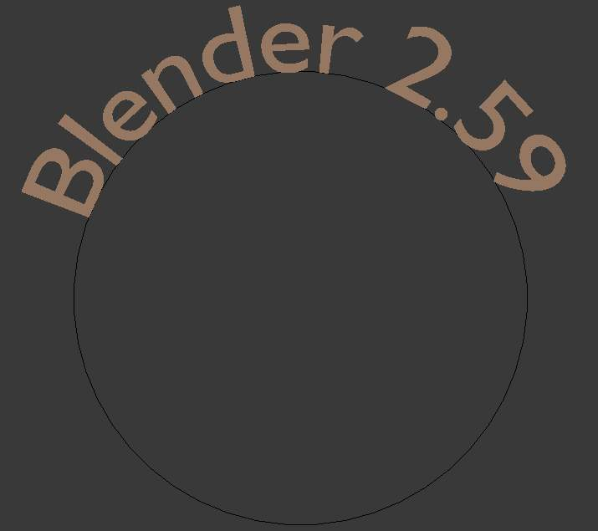
Text on curve.
In (Text on curve) you can see a text deformed by a curve (a 2D Bézier circle).
To apply the curve modifier, the text object first has to be converted to a mesh, using Alt-C and click mesh.
Note
There is also a Text on Curve feature, but the curve modifier offers more options.

Underline
Underline
Toggled with the Underline button before typing. Text can also be set to Underlined by selecting it then using the Underline button in the Tool Shelf.
Position
This allows you to shift vertically the position of the underline.
Thickness
This controls the thickness of the underline.
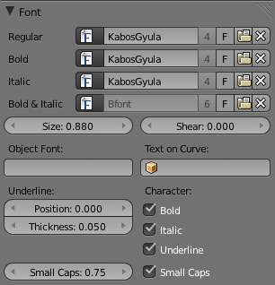
check a character option to, for example, type bold text

Character
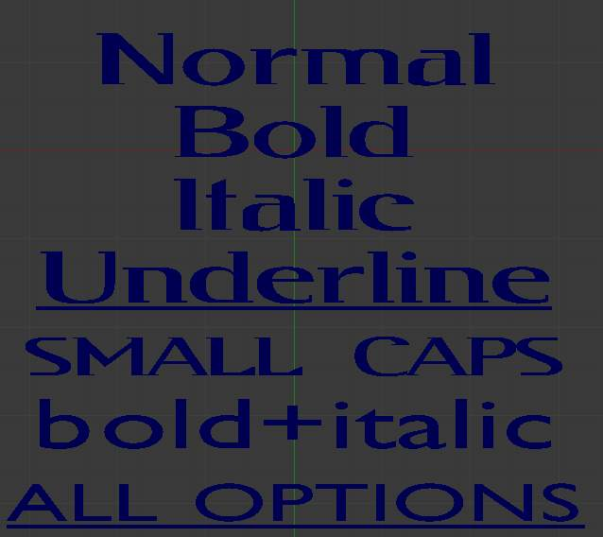
Bold text.
Bold
Toggled with the Bold button before typing. Text can also be set to Bold by selecting it then using the Bold button in the Tool Shelf.
Italics
Toggled with the Italic button before typing. Text can also be set to Italic by selecting it then using the Italic button in the Tool Shelf.
Underline
Enables underlining, as controlled by the Underline settings above.
Small Caps
type small capital text.
Bforartists’s Bold and Italic buttons don’t work the same way as other applications, as they also serve as placeholders for you to load up other fonts manually, which get applied when you define the corresponding style; see Fonts.
To apply the Bold/Italics/Underline attribute to a set of characters, you either turn on Bold / Italics / Underline prior to typing characters, or highlight (select) first and then toggle Bold/Italics/Underline.

Setting Case
You can change the text case by selecting it then clicking the To Upper or To Lower in the tool shelf.
Enable the Small Caps option to type characters as small caps.
The size of the Small Caps can be changed with the Small Caps Scale setting. Note that the Small Caps Scale is applied the same to all Small Caps formatted characters.

Paragraph
The Paragraph Panel has settings for the alignment and spacing of text.
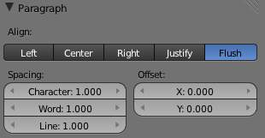
the paragraph tab

Align
Left
Aligns text to left of frames when using them, else uses the center point of the Text object as the starting point of the text (which grows to the right).
Center
Centers text in the frames when using them, else uses the center point of the Text object as the mid-point of the text (which grows equally to the left and right).
Right
Aligns text to right of frames when using them, else uses the center point of the Text object as the ending point of the text (which grows to the left).
Justify
Only flushes a line when it is terminated by a wordwrap (not by Return), it uses whitespace instead of character spacing (kerning) to fill lines.
Flush
Always flushes the line, even when it’s still being entered; it uses character spacing (kerning) to fill lines.
Both Justify and Flush only work within frames.

Spacing
Character
A factor by which space between each character is scaled in width
Word
A factor by which whitespace between words is scaled in width. You can also control it by pressing Alt-Left or Alt-Right to decrease/increase spacing by steps of 0.1.
Line
A factor by which the vertical space between lines is scaled.

Offset
X offset and Y offset
Well, these settings control the X and Y offset of the text, regarding its “normal” positioning. Note that with frames (see Text Boxes), it applies to all frames’ content...

Shape
Reference
Mode: Object or Edit modes
Panel: Curve and Surface (Editing context)

As you can see in the Curve and Surface panel, texts have most of the same options as curves.

Resolution
Preview, Render resolution. See curve resolution.
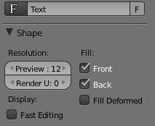
the shape settings
Fast Editing
disables curve filling while in edit mode.

Fill
The fill options control how the text curves are filled in when text is Extruded or Beveled in the Geometry Panel.
Front
Fills in the front side of the surface.
Back
Fills in the back side of the surface.
Fill Deformed
Fills the curves after applying shape keys and modifiers.

Textures
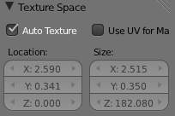
Texture Settings
Use UV for Mapping
Use UV values as generated texture coordinates.
Auto Texture Space
Adjusts the active object’s texture space automatically when transforming object.

Geometry
Text objects have all the curves extrusion features.

Text Editing

Text Boxes
Reference
Mode: Object or Edit modes
Panel: Font (Editing context)

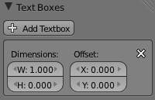
Text frame.
Text “Boxes” allow you to distribute the text amongst rectangular areas within a single text object. An arbitrary number of freely positionable and re-sizable text frames are allowed per text object.
Text flows continuously from the lowest-numbered frame to the highest-numbered frame with text inside each frame word-wrapped. Text flows between frames when a lower-numbered frame can’t fit any more text. If the last frame is reached, text overflows out of it.
Text frames are very similar to the concept of frames from a desktop publishing application, like Scribus. You use frames to control the placement and flow of text.
Frames are controlled in the Text Boxes panel.

Frame size
By default the first frame for a new text object, and any additional frames, has a size of zero for both Width and Height, which means the frame is initially not visible.
Frames with a width of 0.0 are ignored completely during text flow (no wordwrap happens), and frames with a height of 0.0 flow forever (no flowing to the next text frame).
In order for the frame to become visible, the frame’s Width must be greater than 0.0.
Note
Technically the height is never actually 0.0 because the font itself always contributes height.

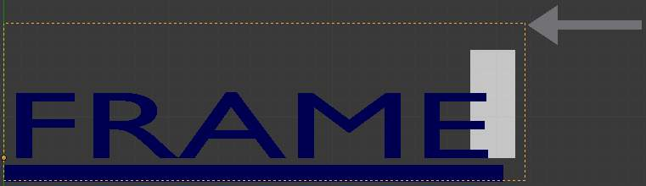
Frame width.
(Frame width) is a text object with a width of 5.0. And because the frame width is greater than 0.0 it is now visible and is drawn in the active theme color as a dashed rectangle. The text has overflowed because the text has reached the end of the last frame, the default frame.

Adding/Deleting a Frame
To add a frame click the Add Textbox button on the Text Boxes panel. A new frame is inserted just after (in text flow order) the current one, with its attributes (position and size). Be sure to modify the offset for the new frame in the X and/or Y fields. Just an X modification will create a new column.
To delete the current frame, click the Delete button. Any text in higher frames will be re-flowed downward into lower frames.

Example: Text Flow
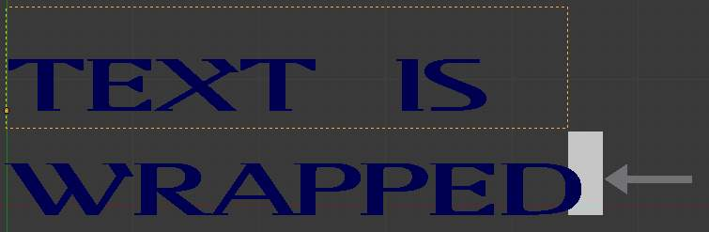
wrapping
With two or more frames you can organize text to a finer degree. For example, create a text object and enter Bforartists is super duper. This text object has a frame; it just isn’t visible because its Width is 0.0.
Set the width to 5.0. The frame is now visible and text is wrapping according to the new width, as shown in (Text 2). Notice that the text has overflowed out of the frame. This is because the text has reached the end of the last frame, which just happens to be the default/initial frame.
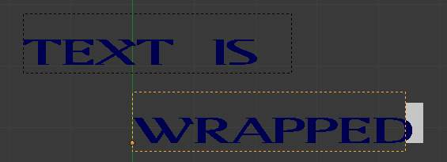
text flowing from box 1 to box 2
When we add another frame and set its width and height, the text will flow into the new frame.

Example: Multiple columns
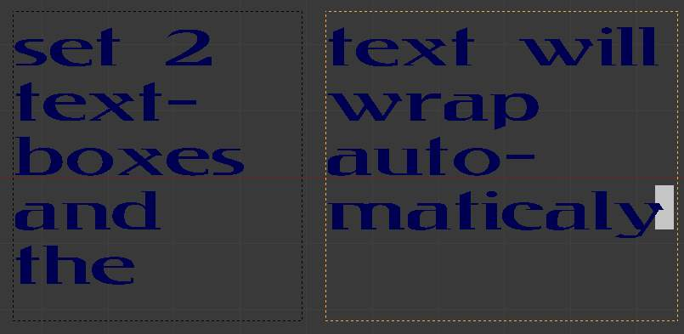
Text 5.
To create two columns of text just create a text object and adjust the initial frame’s Width and Height to your requirements, then insert a new frame. The new frame will have the same size as the initial frame. Set the X position to something greater or less than the width of the initial frame; see (Text 5).

Assigning Materials
Reference
Mode: Edit mode
Panel: Link and Materials (Editing context)

Each character can have a different Material index in order to have different materials on different characters.
You can assign indices either as you type, or after by selecting blocks of text and clicking on the Assign button in the Materials panel.
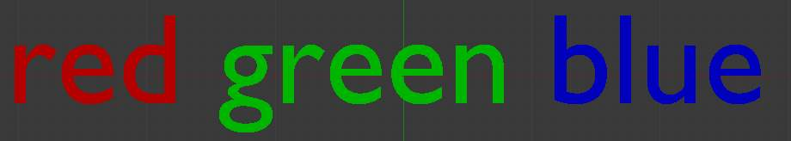
Red Green Blue.
For example, to create (Red Green Blue) you would need to create three separate materials and three separate material indices. Each word would be assigned a Material index by selecting the characters for each word and clicking the Assign button. (Red Green Blue) is still one single Text object.

